**Project Design Phase-II**

**Data Flow Diagram &User Stories**

|  |  |
| --- | --- |
| Date | 03October 2022 |
| Team ID | PNT2022TMID45109 |
| Project Name | Project - News Tracker Application |
| Maximum Marks | 4 Marks |

**Data Flow Diagrams:**

A Data Flow Diagram (DFD) is a traditional visual representation of the information flows within a system. A neat and clear DFD can depict the right amount of the system requirement graphically. It shows how data enters and leaves the system, what changes the information, and where data is stored.

1. *User log in to the application*
2. *Validate user details with the records in the IBM DB*
3. *News API gives the headlines after login*
4. *User click the headlines to get the whole news*
5. *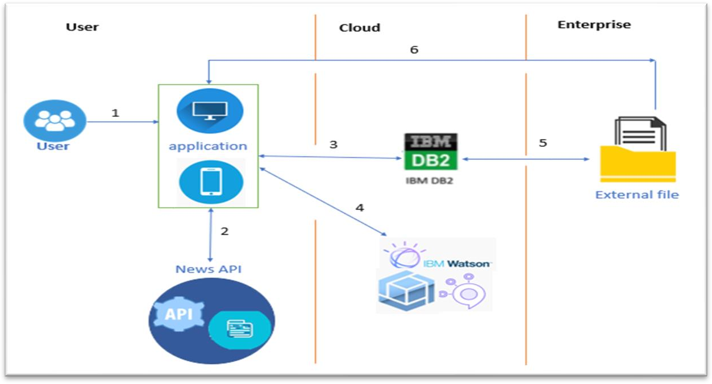User can download the news to read it in offline mode*
6. *Watson assistant is used to clear doubts if needed*

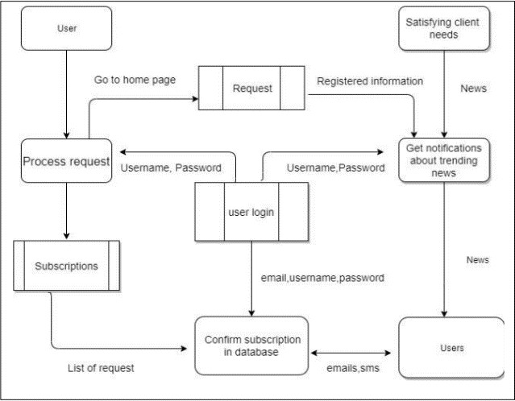

**User Stories**

Use the below template to list all the user stories for the product.

| **User Type** | **Functional Requirement (Epic)** | **User Story Number** | **User Story / Task** | **Acceptance criteria** | **Priority** | **Release** |
| --- | --- | --- | --- | --- | --- | --- |
| Customer (Mobile user) | Registration | USN-1 | As a user, I can register for the application by entering my email, password, and confirming my password. | I can access my account / dashboard | High | Sprint-1 |
|  |  | USN-2 | As a user, I will receive confirmation email once I have registered for the application | I can receive confirmation email & click confirm | High | Sprint-1 |
|  |  | USN-3 | As a user, I can register for the application through Facebook | I can register & access the dashboard with Facebook Login | Low | Sprint-2 |
|  |  | USN-4 | As a user, I can register for the application through Gmail |  | Medium | Sprint-1 |
|  | Login | USN-5 | As a user, I can log into the application by entering email & password |  | High | Sprint-1 |
|  | Dashboard | USN-6 | To see their histories about recently viewed, updates for search related news, current progress, feedback |  |  |  |
| Customer (Web user) | Browser | USN-7 | Have interactive medium between client and server | I have a clarity to use this application and easily resolve my specific issues | High | Sprint-1 |
| Customer Care Executive | Chat bot | USN-8 | Rectify the issues related  subscription, account, terms and conditions, privacy policy |  |  |  |